Case Diagram - Government and Independences (after the review)

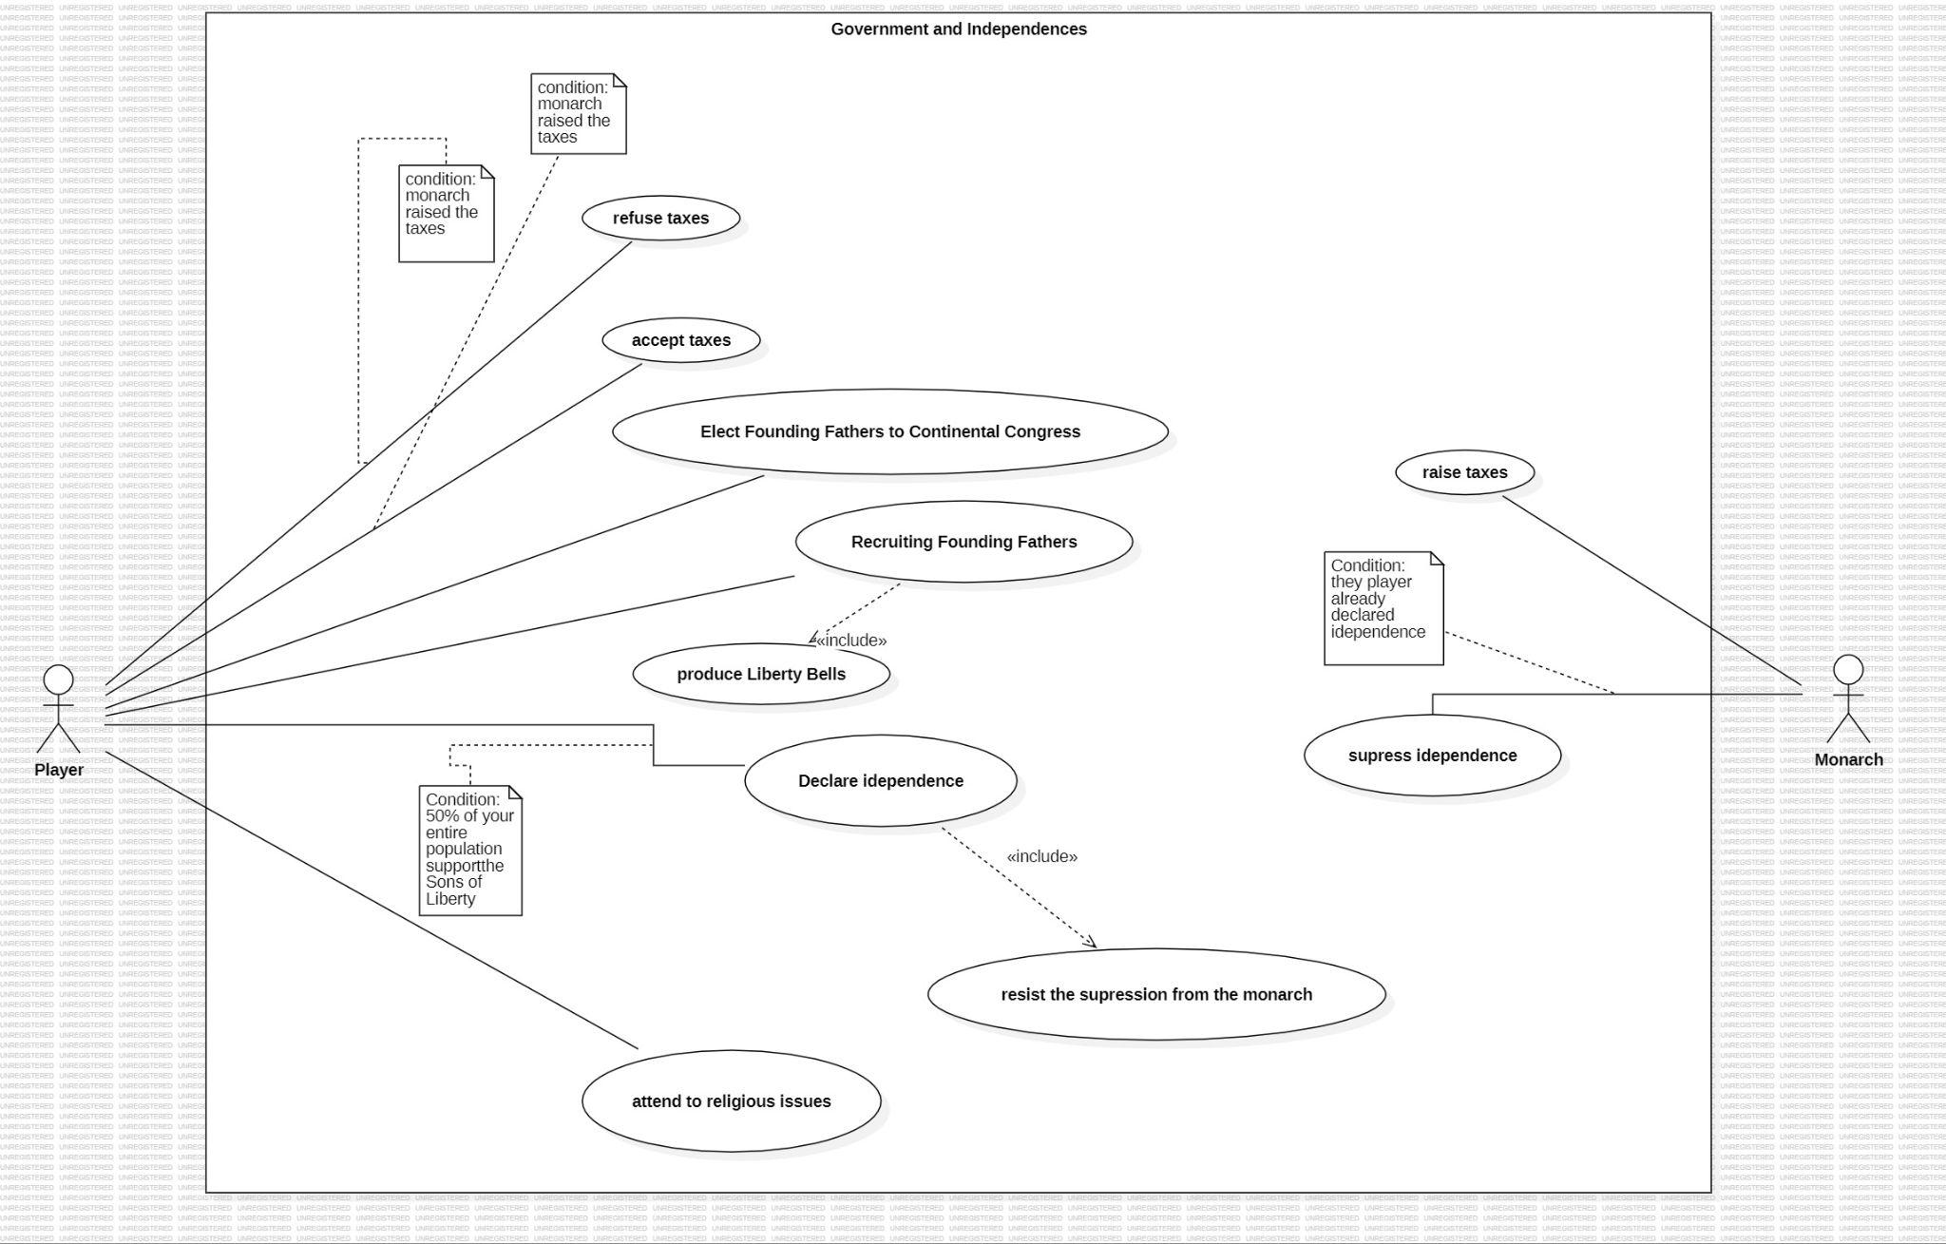

The main actor in this use case diagram is the “Player”, i.e., the human Player who is playing the game. We also have a Secondary actor, Monarch, that is an AI.

The main actor can interact with this context by:

1. **Refusing the taxes** that are imposed by the Monarch, you can only do it if the monarch raises the taxes.
2. **Accepting the taxes** that are imposed by the Monarch,you can only do it if the monarch raises the taxes.
3. **Elect Founding Fathers to Continental Congress,** they will represent you and give benefits for your nation.
4. **Recruiting Founding Fathers,** when you produce Liberty Bells you will be allowed to recruit founding fathers. They can assist you in different ways, and each of them have different benefits.
5. **Declare Independence,** opposing the Monarch, and being free to not pay the taxes but initiating a conflict. This implies that the Monarch will try to suppress your rebelion, if so you will fight for your freedom as an independent territory.
6. **Attending religious Issues** may let your colony members be satisfied with your administration.It could be a good idea if the player wants to maintain the peace in your territory.

Rodrigo Fernandes - 63191